LIPIDOMICS IMPACT ON CANCER, METABOLIC AND INFLAMMATORY DISEASES:
LIPID MAPS Annual Meeting MAY 12-13, 2015

Tuesday, May 12 Scripps Seaside Forum – UCSD

7:15 – 8:30 AM – Registration and Breakfast Buffet / Poster Setup
8:30 – 8:45 AM – Welcome [Edward A. Dennis (University of California, San Diego), Chair]
8:45 – 10:15 AM – Metabolomics [Shankar Subramaniam (University of California San Diego), Chair]
- 8:45 Michael Snyder (Stanford University) – Dynamic global changes during disease onset and dietary perturbations revealed using multiomics profiling
- 9:15 David Wishart (Human Metabolomics, Canada) – Translational Lipidomics: Linking Lipidomics to Laboratory Medicine
- 9:45 Daniel K. Nomura (University of California, Berkeley) – Mapping dysregulated metabolic pathways in disease using functional metabolomic platforms
10:15 – 10:45 AM – Coffee Break
10:45 – 12:45 PM – Lipidomics of Cancer [Alfred H. Merrill, Jr. (Georgia Institute of Technology), Chair]
- 10:45 Tony Futerman (Weizmann Institute, Israel) – The role of sphingolipids with different acyl chains in human disease
- 11:15 Marion B. Sewer (University of California, San Diego) – Deoxysphinganines as regulators of breast cancer cell growth
- 11:45 Huiyong Yin (Shanghai Institutes for Biological Sciences, China) – Lipidomics of Human Heptacellular Carcinoma (HCC): New insights into the roles of lipid metabolism and mitochondrial function
- 12:15 Christian Metallo (University of California, San Diego) – Regulation of lipid and mitochondrial metabolism by the microenvironment
12:45 – 1:00PM – Group Photo
1:00 – 2:00 PM – Lunch
2:00– 3:30 PM – Eicosanoids and the Inflammatory Response [Takao Shimizu (University of Tokyo and National Center for Global Health and Medicine, Tokyo), Chair]
- 2:00 Nicolas G. Bazan (Louisiana State University) – Omega-3 fatty acid metabolites and neurodegeneration
- 2:30 Valerie O’Donnell (Cardiff University, UK) – Mapping the diversity of the human platelet lipidome
- 3:00 Ian A. Blair (University of Pennsylvania) – Monitoring dysregulated mitochondrial metabolism using human platelets
3:30 – 4:00 PM – Lightning Talks from Poster Abstracts [Mohit Jain (University of California, San Diego), Chair]
4:00 – 6:00 PM – Poster session & Reception
6:00 – 8:30 PM – Dinner

Lightning Talks
Tuesday, May 12, 3:30 - 4:00 PM
- 3:30 Aditi Das (University of Illinois Urbana-Champaign, IN) – Elucidating the metabolism of omega-3 and omega-6 endocannabinoids by cardiac CYP2J2 epoxygenase in Nanodiscs – Poster #5
- 3:35 William H. Gerwick (University of California, San Diego, CA) – Mooreamide A: A cannabinomimetic lipid from the marine cyanobacterium Moorea bouillonii – Poster #9
- 3:40 Berit Johansen (Norwegian University of Science and Technology, Norway) – Novel inhibitor of cytosolic group IVA phospholipase A2 (cPLA2α) ameliorate mesangial inflammation and kidney fibrosis development in diabetic neuropathy – Poster #17
- 3:45 Samira Khakpour (University of California, San Francisco, CA) – The endocannabinoid N-arachidonoyl dopamine (NADA) regulates endothelial prostanoid metabolism – Poster #19
- 3:50 Matthew A. Mitsche (UT Southwestern Medical Center, TX) – Isotopomer spectral analysis of cholesterol biosynthesis in vivo reveals multiple tissue-specific, flux-dependent pathways – Poster #27
- 3:55 Ryo Morimoto (National Center for Global Health and Medicine and The University of Tokyo, Japan) – Regulatory mechanisms of platelet-activating factor (PAF) production in macrophages and identification of a specific inhibitor for PAF synthetic enzyme (LPCAT2) by high-throughput screening – Poster #29

Wednesday, May 13, 12:00 - 12:30 PM
- 12:00 Jaewoo Choi (Linus Pauling Institute, OR) – Untargeted lipidomics reveals loss of key phospholipids and several lysophospholipids from vitamin E-deficient zebrafish brains – Poster #4
- 12:05 Mikhail Y. Golovko (University of North Dakota, ND) – Tissue metabolomic analysis of bioactive lipids requires tissue fixation with focused microwave irradiation – Poster #10
- 12:10 Zoe Hall (MRC Human Nutrition Research, UK) – Mass spectrometry imaging reveals lipid biochemistry aberrations in Myc-dependent lung tumours – Poster #12
- 12:15 Andrew Kim (University of California, San Francisco, CA) – TMEM16F plays a crucial role in membrane lipid scrambling, hemostasis/thrombosis and lipid metabolism – Poster #18
- 12:20 Lior Mayo (Brigham and Women’s Hospital, MA) – B4GALT6 regulates astrocyte activation during CNS inflammation – Poster #28
- 12:25 Rushdia Z. Yusuf (Harvard Stem Cell Institute, MA) – Aldehyde dehydrogenases as a source of fatty acids in cancer stem cells – Poster #44
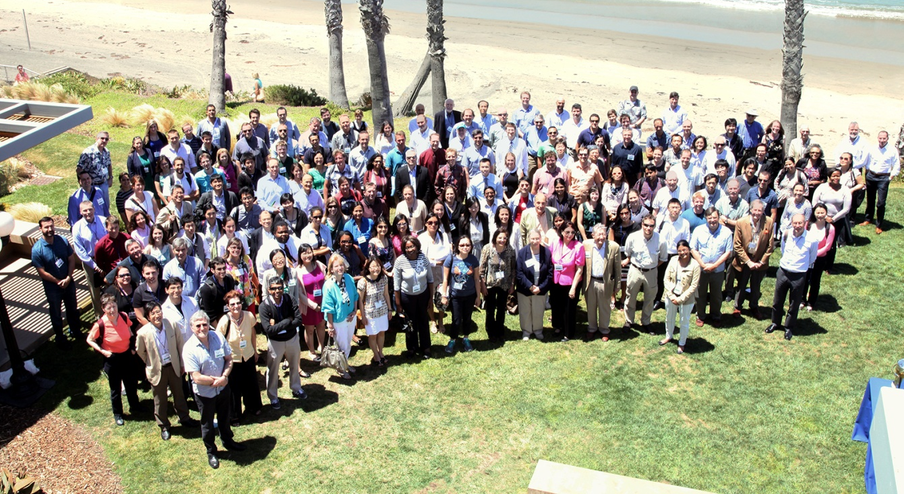
2014 LIPID MAPS Meeting Photo by Alvin Angeles

LIPID MAPS Meeting 2009
Wednesday, May 13 Scripps Seaside Forum – UCSD
7:45-8:30 AM – Breakfast Buffet
8:30 – 10:00 AM – Lipidomics and Metabolic Disease [Dennis Vance (University of Alberta), Chair]
- 8:30 Hiroyuki Arai (University of Tokyo, Japan) – Remodeling of fatty acyl chains in phosphatidylinositol
- 9:00 Jean Vance (University of Alberta, Canada) – Phosphatidylserine and phosphatidylethanolamine in Lenz-Majewski Syndrome and mitochondrial function
- 9:30 George M. Carman (Rutgers University) – Physiological functions and regulation of phosphatidate phosphatase
10:00 – 10:30 AM – Coffee Break
10:30 – 12:00 PM – Lipid Interactions with Membrane Proteins [William Gerwick (Scripps Institution of Oceanography, University of California, San Diego), Chair]
- 10:30 Shelagh Ferguson-Miller (Michigan State University) – Crystal structures of Translocator Protein 18 kDa (peripheral benzodiazepine receptor) reveal membrane lipid and ligand binding sites
- 11:00 Robert M. Stroud (University of California, San Francisco) – Effective lipids on membrane proteins
- 11:30 Marcia E. Newcomer (Louisiana State University) – The structural basis for the control of lipoxygenase activity

12:00 – 12:30 PM – Lightning Talks [Christopher K. Glass (University of California, San Diego), Chair]
12:30 – 2:30 PM – Lunch and Poster session
2:30 – 4:30 PM – Lipids and Immunity [Oswald Quehenberger (University of California, San Diego), Chair]
- 2:30 Jason G. Cyster (University of California, San Francisco) – Lipid mediators guide the adaptive immune response
- 3:00 Steven Bensinger (University of California, Los Angeles) – Understanding the role of sterol metabolism in immunity
- 3:30 Hugh Rosen (The Scripps Research Institute) – S1PR1 modulators: Screening, structure and clinical solutions
- 4:00 Alan Aderem (Seattle Biomedical Research Institute) – A systems approach to dissecting immunity
4:30 PM – Closing Remarks and Adjournment
4:45 – 5:15 PM – Coffee

